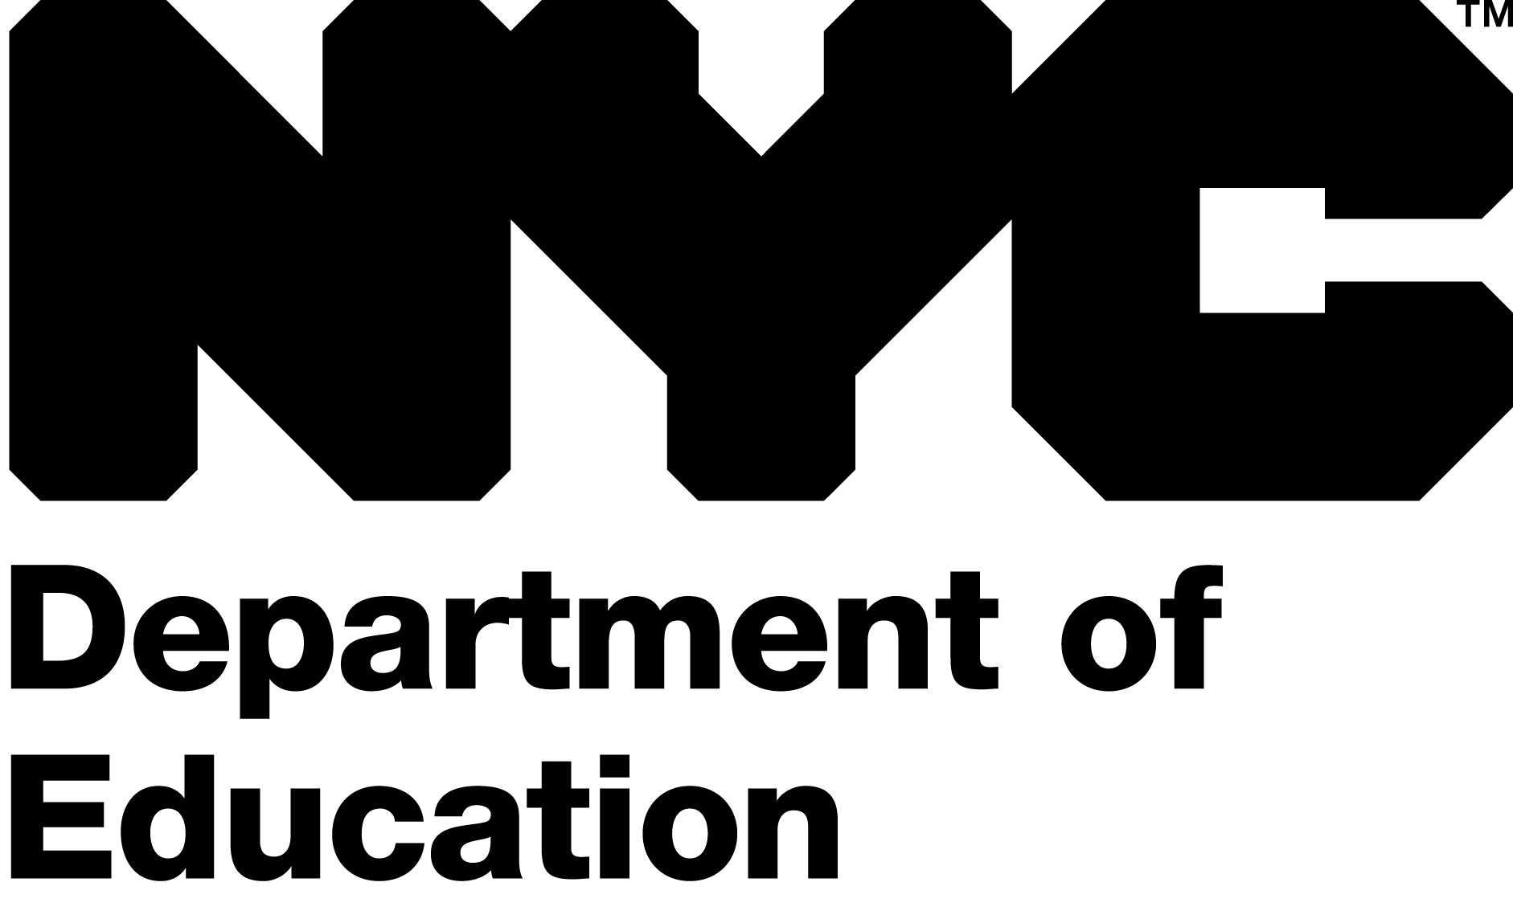

Occupational Therapy /
Physical Therapy
Scholarship Program Application

2010-2011

New York City Department of Education

Office of Related & Contractual Services

49-51 Chambers Street, Room 600

New York, NY 10007

The Scholarship Program

Since 1990, in order to address staffing shortages, the New York City Department of Education has offered a scholarship program in Occupational and Physical Therapy.

Students in their 3rd, 4th or graduate year of professional study at participating colleges or universities (a listing of which follows) in New York State Education Department accredited programs leading to certification in the shortage areas of Occupational and Physical Therapy are eligible to apply. Scholarships will be granted through a selection process involving an interview and review of academic records, writing samples and references, and is contingent upon continued funding for the program.

PLEASE NOTE: Current Department of Education employees will not receive special accommodations.

Student Eligibility
All applicants must:
- be accepted by one of the participating colleges or universities and enrolled full time in an Occupational or Physical Therapy Program leading to New York State Certification.

- certify that they are citizens or legal permanent resident aliens of the United States and will present proof of such at the time of the interview.

- certify that he/she does not possess a disqualifying record of conviction. All awardees need to be fingerprinted and receive clearance by the New York City Department of Education.

- agree to accept employment as Occupational or Physical Therapists with the New York City Department of Education within six months of graduation from one of the participating colleges or universities and commit to serve for a determined period of time.

(5) agree to maintain a full time college or university enrollment before the completion of the required courses

(6) complete the Application for Scholarship and return to Office of Related and Contractual Services postmarked no later than May 7th, 2010 and be available for individual interviews between May and June 2010.

Participating Colleges/Universities:

For your reference, the schools listed below are those currently under contract with the Department of Education from September 2009 through August 2014.

Occupational Therapy
Columbia University Master’s Degree Program
D’Youville College Master’s Degree Program
Ithaca College Dual Degree Program
Keuka College Master’s Degree Program
Long Island University at Brooklyn Dual Degree Program
Mercy College Master’s Degree Program
New York Institute of Technology Master’s Degree Program
New York University Master’s Degree Program
SUNY Health Science Center at Brooklyn Master’s Degree Program
Touro College at Manhattan / Bay Shore Master’s Degree Program
Utica College
York College Dual Degree Program

Physical Therapy
Columbia University Doctoral Program
CUNY College of Staten Island Master’s Degree Program
D’Youville College Doctoral Program
Long Island University at Brooklyn Dual Degree Program and
Doctoral Program
Mercy College Master’s Degree Program
New York Institute of Technology Doctoral Program
New York Medical College Doctoral Program
New York University Doctoral Program
Touro College at Manhattan / Bay Shore Doctoral Program
Utica College

Eligible Institutions
Funds will be provided for scholarship awardees attending participating schools:

- whose programs are accredited by the New York State Education Department in the fields of Occupational or Physical Therapy.
- who have completed the Occupational Therapy/Physical Therapy Scholarship Agreement Contract and meet the deadline date for submission of required documentation.

Awards

Award amounts will:

- be granted for one year and may be renewable for the second year, contingent upon funding and acceptable academic records.

- cover the full cost of tuition only for courses directly related to programs in Occupational or Physical Therapy (during professional phase of program).

All application fees, books, room/board and other fees are not included.

NOTE: The maximum number of years that one is allowed to participate in the scholarship program is two (specifically the last two years of study in that program) – regardless of the length of your study/program.

In dual degree programs (combination undergraduate and graduate), only the last two years of professional study will be eligible for scholarship payment.

Service Obligation

The service obligation requirement is a period of twenty-four months (each twenty-four month period must include service during two 10-month school years) of employment with the New York City Department of Education within the field of either Occupational or Physical Therapy for each year of scholarship assistance provided. If an awardee receives less than one year of scholarship assistance, the minimum service obligation requirement remains a twenty-four month period (two 10 month school years).

An awardee must commence employment with the New York City Department of Education within six (6) months of graduation. An awardee must possess a New York State license to practice Occupational or Physical Therapy.

The awardee who has failed to commence his/her service obligation will be required to repay the total year plus nine (9%) interest within one (1) year of the last award semester. A pro-rated repayment schedule shall be established for any awardee that completes only a portion of his/her service obligation within the specified period.

Occupational Therapy/Physical Therapy Scholarship Program Application 2010-2011
Please print clearly and note that all areas must be completed in order for the applicant to be considered.

Return to: NYC Department of Education, Office of Related and Contractual Services
49-51 Chambers Street, Room 600, New York, NY 10007
Tel.: (212) 374-1081
Discipline for which I am applying: □ OT □ PT
Name: Mr./Ms. | Last First Middle Initial
Social Security No.: | __________--________--____________
Permanent Address: | Number and Street Apt. No.
 | City State Zip Code
 | Area Code Telephone Number
Mailing Address:  (if different from above) | Number and Street Apt. No.
 | City State Zip Code
 | Area Code Telephone Number

Applications for admission to the participating schools must be completed prior to the submissions of this application. Please contact each school for admission deadlines.

Please check one of the following:
□ I have applied to: □ I have been accepted and will attend: □ I am on the waiting list for: □ I currently attend:
Name and location of college/university __________________________________________________________________________________________

I will begin my third (3rd), fourth (4th) or graduate year of professional studies _____________________________________
Month Year

My anticipated date of graduation is ___________________________________
Month Year
I maintain that I do not possess a disqualifying record of conviction: □ Yes □ No -- I am a citizen or legal permanent Resident Alien of the United States: □ Yes □ No

All recipients of Occupational/Physical Therapy Scholarships must maintain a full time enrollment for the completion of their studies and are required to comply with a service obligation of a period of twenty-four months (each twenty four month period includes 2 ten month school years) of employment for each year of scholarship funding from the New York City Department of Education. If funding is for less than a year, the minimum service requirement remains 2 ten month school years. All awardees need to be fingerprinted and receive clearance by the New York City Department of Education. Your signature on this application attests to your understanding of this service obligation.

_____________________________________________________________ _______________________________________
Signature Date

Postmark no later than May 7th, 2010. Late applications will not be processed for this school year. We cannot be held responsible for lost applications.

